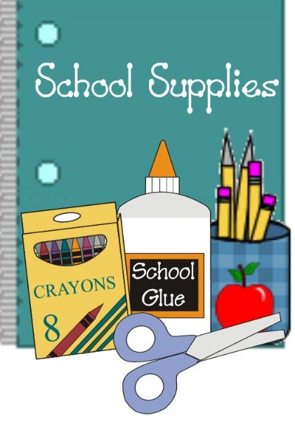
First Grade Supply List

We share all of these supplies as a class!
Please do not put your child’s name on items.

1 back pack with no wheels (labeled & full size, no rolling/mini backpacks)
1 1 inch binder (label your child’s name for portfolio)
1 Head Phones-Label your child’s name (No ear buds)
2 24 box of Crayola crayons
1 pack of Crayola markers
1 pack No. 2 pencils, sharpened
1 pack of Expo Dry Erase Markers
2 pack of Elmer’s glue sticks

1 Five Star 2 Pocket Plastic Folder with Prongs

2 boxes of tissues
3 containers Disinfectant Wipes (Clorox/ Lysol)
1 package of baby wipes
2 rolls of paper towels
4 containers of Play-Doh
1 Package Sandwich Ziploc Bags
1 Package of gallon Ziploc Bags
1 Package Band-Aids

